Chuanjie ZANG

699382953

Step 1 : I chose to start at the right angle of the top right corner, which is the concave upper right corner of the note. This is because I think the right angle allows for a clear starting point in the curve pattern.

Step 2 : Select the 'pen tool' and click on the right angle in the top right corner, then select a position on the grey line on the right side and click hold and drag so that the curve roughly overlaps the grey section.

Step 3 : Repeat the previous step until roughly traced the entire grey pattern.

Step 4 : Be sure to note during the process that there are 2 right-angled points in the entire note pattern, located in the upper right and lower left corners. In addition, in the drawing process, you can add and reduce the anchor points according to the need, after completing the adjustment of the curves on both sides of some anchor points, you can delete this anchor point, because the less anchor ponit will make the curve smoother.

In addition, you can use the 'pen tool' to switch between smooth points and corner points by alt+left clicking.

Step 5 : After several adjustments, the finished result is as follows.

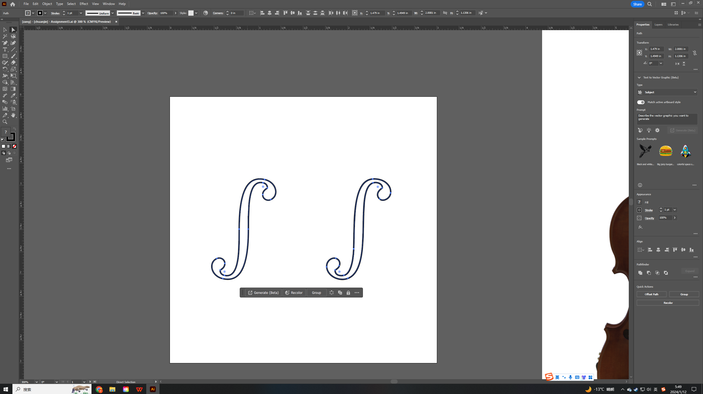

Step 6 :Duplicate an S-pattern, select one of them and choose object-transform-reflect to mirror the pattern

Step 7 : Drag and place the 2 S patterns to the correct position on the violin.

